MongoDB Lab – Day 5 (Indexing & Sorting)
Schema
{ emp_id, name, department, designation, city, salary, experience }
Initial Data:
Emp ID | Name | Department | Designation | City | Salary | Experience
101 | Amit | IT | Developer | Kolkata | 60000 | 3
102 | Neha | HR | HR Executive | Delhi | 45000 | 2
103 | Ravi | IT | Tester | Mumbai | 50000 | 4
104 | Pooja | Finance | Accountant | Chennai | 55000 | 5
105 | Karan | IT | Developer | Kolkata | 65000 | 6
106 | Sneha | HR | Manager | Delhi | 70000 | 7
107 | Arjun | Finance | Analyst | Mumbai | 48000 | 2
108 | Meera | IT | Developer | Bangalore | 75000 | 8
109 | Rohit | IT | Team lead | Pune | 90000 | 10
110 | Anjali | HR | Recruiter | Kolkata | 42000 | 1

Lab Questions
Q1. Display all employee records.
Query: db.employees_cse_204.find().pretty()
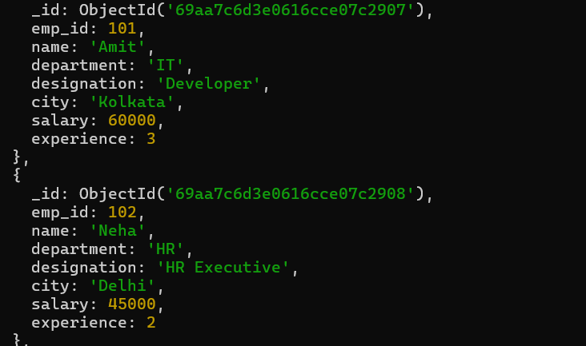
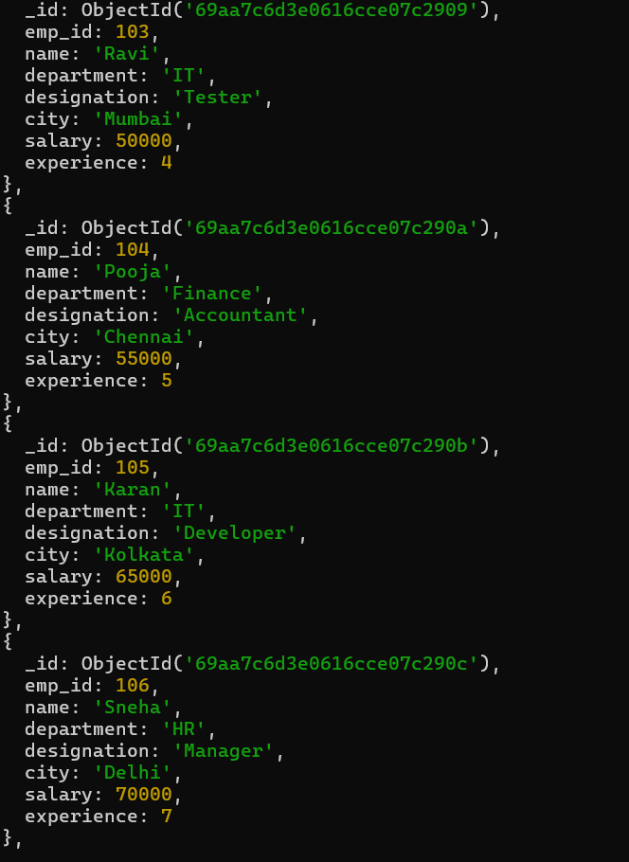
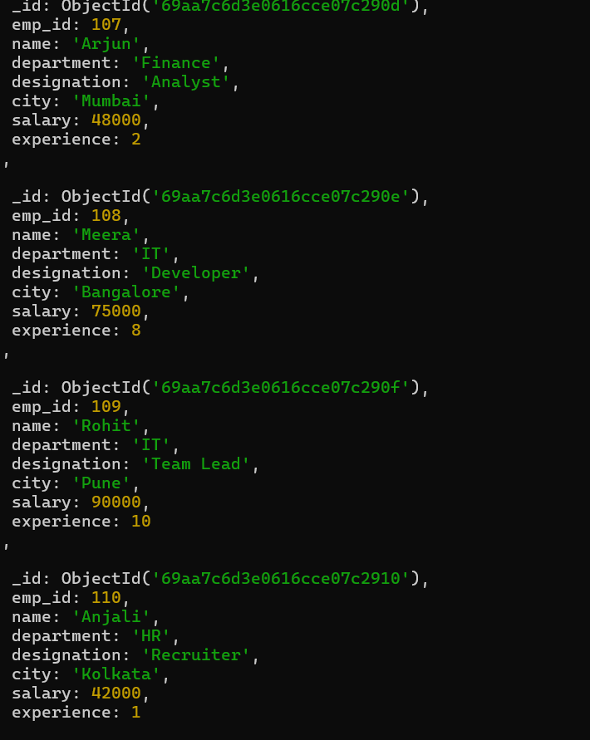

Q2. Create an index on emp_id field.
Query: db.employees_cse_204.createIndex({ emp_id: 1 })
Output: emp_id_1

Q3. Create an index on department field.
Query: db.employees_cse_204.createIndex({ department: 1 })
Output: department_1
Q4. Create a compound index on department and salary.
Query: db.employees_cse_204.createIndex({ department: 1, salary: 1 })
Output: department_1_salary_1
Q5. Find employees working in IT department.
Query: db.employees_cse_204.find({ department: "IT" })
Output: 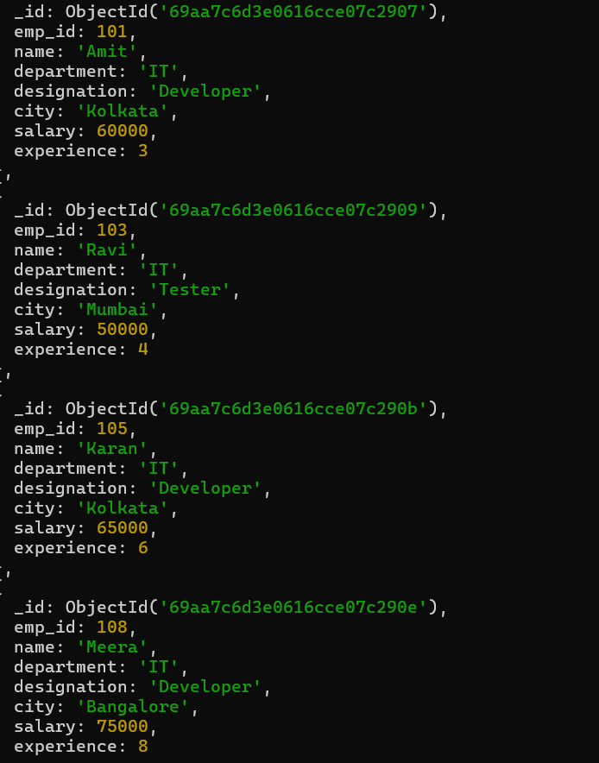
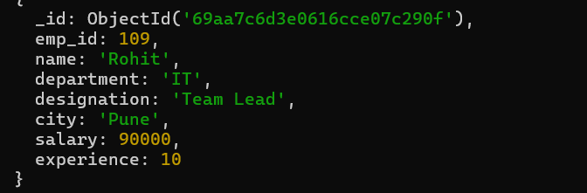

Q6. Display employees whose salary is greater than 60,000.
Query: db.employees_cse_204.find({ salary: { $gt: 60000 } })
Output: 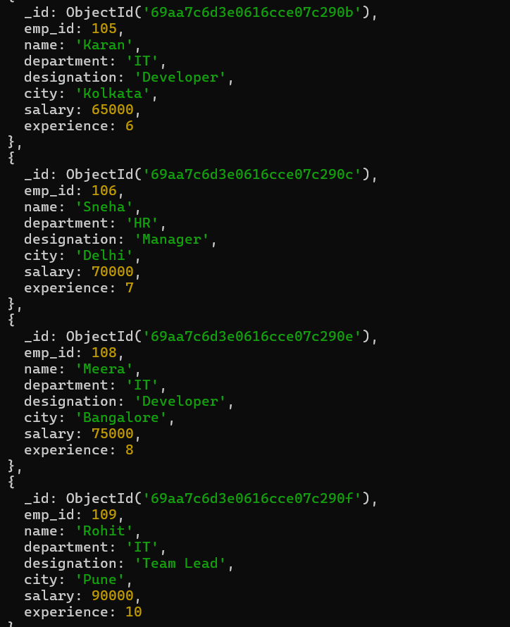

Q7. Sort employees by salary in descending order.
Query: db.employees_cse_204.find().sort({ salary: -1 })
Output: 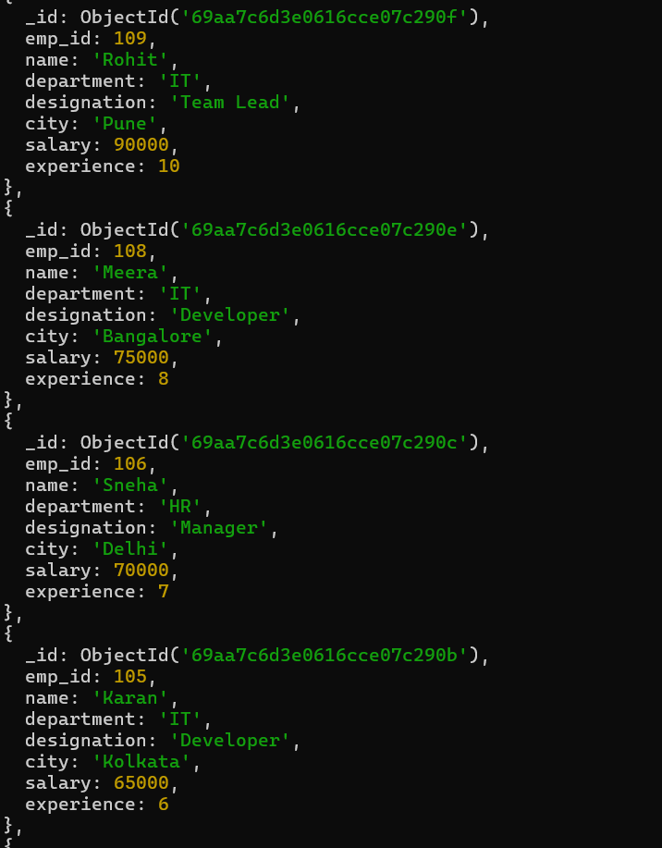
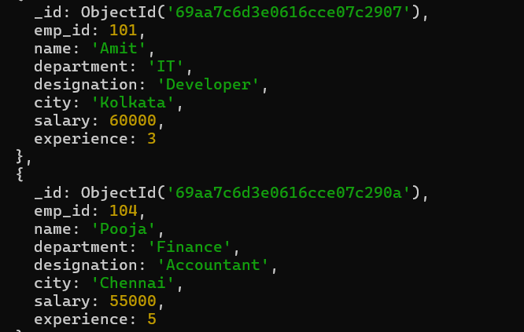
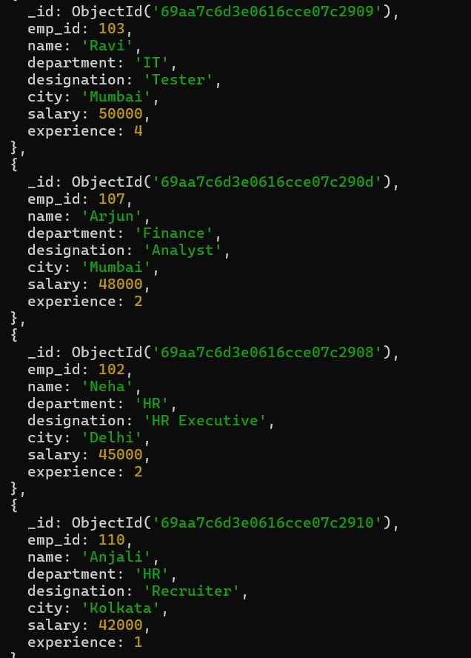

Q8. Display top 3 highest paid employees.
Query: db.employees_cse_204.find().sort({ salary: -1 }).limit(3)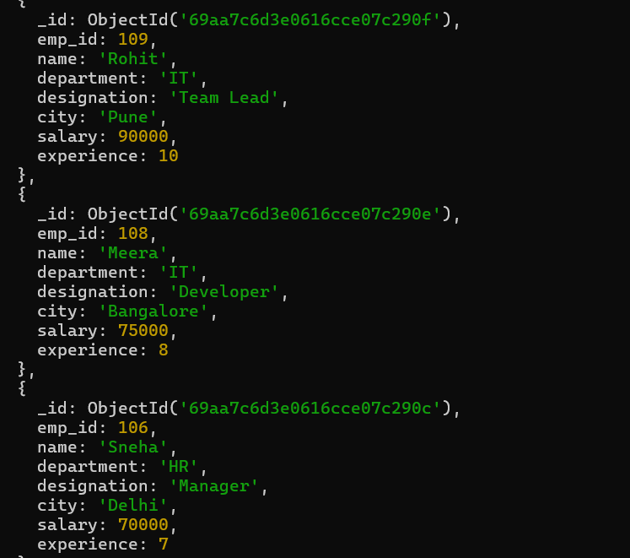
Q9. Display employees having experience more than 5 years.
Query: db.employees_cse_204.find({ experience: { $gt: 5 } })
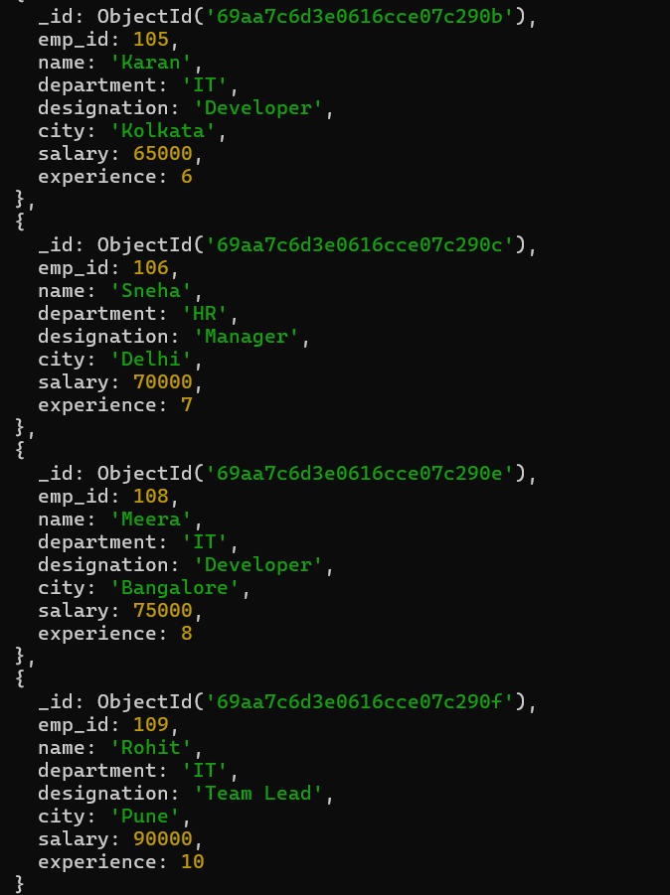

Q10. Analyze query performance using explain().
Query: db.employees_cse_204.find({ department: "IT" }).explain("executionStats")
